You've asked for a precise description of the differences between member ID, membership ID, membership resource ID, and proxy ID. Based on 42,804 matching internal files and several relevant documents, here's a clear breakdown of each identifier and how they relate to one another in your enterprise systems:

🔹 Member ID
- Definition: A system-specific identifier used to locate a member’s file, often tied to SSN or CUMB ID.
- Usage: Primarily used for searching and retrieving member records in systems like OneCM and GPS.
- Format: Typically a 12-digit alphanumeric string.
- Context: Appears in systems like EDW and CEE, and is used in APIs such as /cee_members/{id}/communications [1] [2] [3].

🔹 Membership ID
- Definition: Identifies a specific enrollment instance or benefit plan association for a member.
- Usage: Used to differentiate between multiple memberships a member may hold (e.g., across different plan sponsors or lines of business).
- Context: Passed to microservices like MembershipsDetailMicroservice to retrieve plan and policy data [4].

🔹 Membership Resource ID
- Definition: A backend identifier used to retrieve specific policy or benefit product details.
- Usage: Often used in conjunction with membership ID and proxy ID to fetch health policy data.
- Context: Invoked via APIs like v3/healthpolicies during member detail flows [4].

🔹 Proxy ID
- Definition: A strategic, stable identifier loosely coupled to an individual ID.
- Usage:
  - Used for external communications and API calls (e.g., v5/individuals/communicationpreferences).
  - Provides flexibility to reassign individual IDs without changing the proxy ID.
  - More secure for external sharing than individual IDs.
- Format: Alphanumeric, typically 12 bytes (e.g., 15~L7Y61BBBBPXZ).
- Context: Central to the Individualization process, enabling consistent identification across systems and time [5] [6].

🔁 How They Interrelate
Identifier | Scope | Stability | Purpose
Member ID | System-specific | Medium | Locates member records in a given system
Membership ID | Enrollment-specific | Medium | Identifies a specific benefit association
Membership Resource ID | Backend-specific | Medium | Retrieves detailed policy or product data
Proxy ID | Cross-system, external | High | Stable external-facing ID that maps to individual/member IDs

Would you like a visual diagram showing how these IDs flow through your architecture or how they’re used in API calls?
References
[1] Member ID
[2] v1-edcs-cee_members-id-communications
[3] Member ID
[4] OneCM Member Search/Detail
[5] Insights - EDW Crosswalk
[6] DI Refresher & Member ID Training

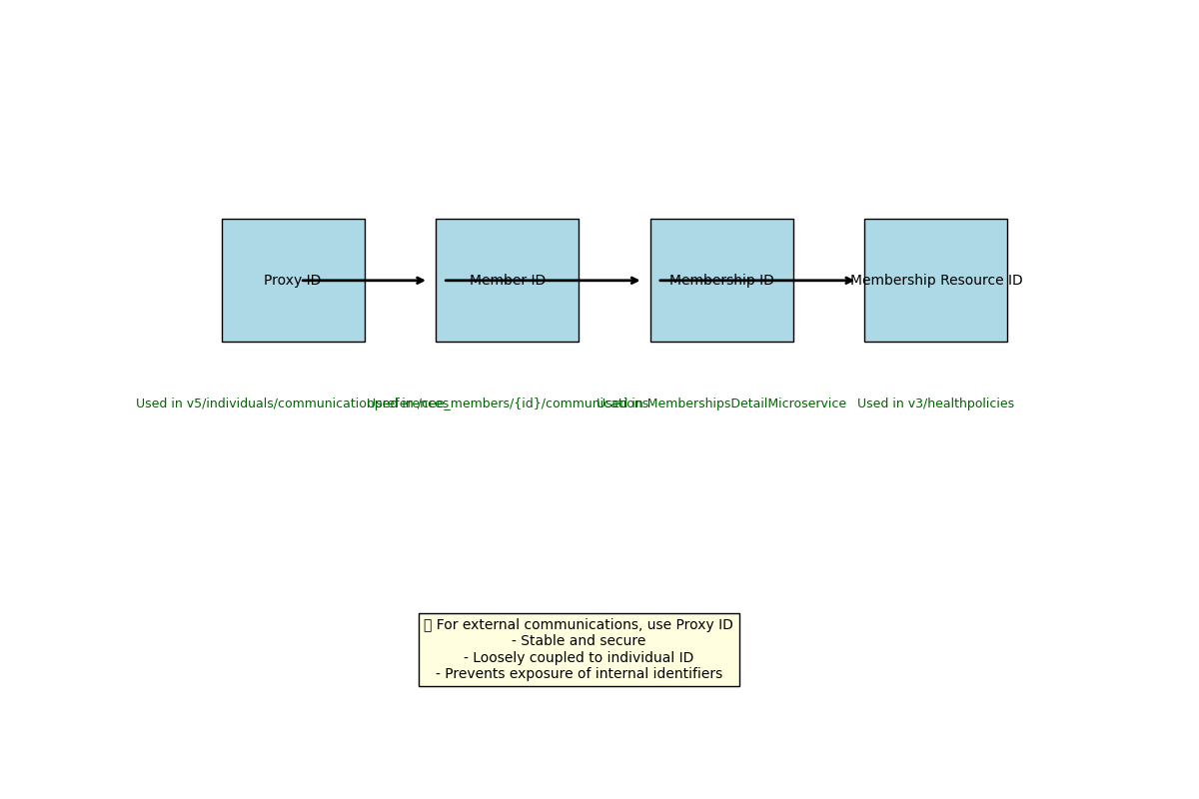

🔍 How These IDs Are Used in API Calls
ID Type | API Usage
Proxy ID | /v5/individuals/communicationpreferences – used for external-facing interactions [1]
Member ID | /cee_members/{id}/communications – used to retrieve member-specific communications [2]
Membership ID | MembershipsDetailMicroservice – used to fetch plan and policy data tied to a member [3]
Membership Resource ID | v3/healthpolicies – used to retrieve detailed health policy information [3]

📤 Which ID Should Be Used for External Communications?
For external communications, always use the Proxy ID:
- ✅ Stable: It remains consistent even if internal identifiers change.
- 🔒 Secure: It avoids exposing sensitive internal IDs like SSNs or system-specific member IDs.
- 🔄 Loosely Coupled: It can be reassigned without affecting the underlying individual record.
- 🌐 Cross-System Friendly: Ideal for APIs and external integrations.
Let me know if you'd like this diagram embedded in a document or presentation, or if you want to explore how these IDs are mapped in your system architecture.
References
[1] Insights - EDW Crosswalk
[2] Member ID
[3] OneCM Member Search/Detail

🧩 What Are Plan Groups?
Plan groups are logical containers that organize plan documents (medical, dental, pharmacy, etc.) by benefit type, membership, and policy. They serve as the backbone for document retrieval services in OpenPlatform and SuperApp.
- At application startup, plan group data is cached internally within the plan groups service—not at the BFF—to avoid redundant calls [1].
- Each plan group is tied to a policyResourceId, which is used to differentiate between medical and dental plans in API calls [2] [3].

🔗 How Are IDs Mapped?
The mapping process involves several layers of identifiers and transformations:
ID Type | Purpose | Mapping Logic
policyResourceId | Primary input to differentiate plan types (e.g., medical vs dental) | Stripped of cache prefix before being passed to the backend [2] [3]
documentId | Unique ID for each plan document | Retrieved from readHealthPoliciesCommunicationContentsResponse [2]
resourceId | Used to construct document URLs for retrieval | Appended to /sa/plandocs/v1/retrieve/ endpoint [2]
planId | Derived from policyResourceId | Used for orchestration and cache lookup [2]
communicationContentIdentifier | Composite key for document metadata | Includes documentType, description, and resourceId [2]
These mappings are documented in the orchestration diagrams and API contracts for OpenPlatform [2].

🛠️ API Usage Patterns
The OpenPlatform BFF (Backend for Frontend) exposes two key endpoints:
- List Retrieval
POST /sa/plandocs/v1/list
- Input: policyResourceId
- Output: Array of available documents for a user and membership [2]
- Document Retrieval
POST /sa/plandocs/v1/retrieve/{resourceId}
- Input: resourceId from communicationContentIdentifier
- Output: PDF document or metadata [2]
These APIs maintain consistency with existing standards and use POST for both list and document retrieval [1].

📤 External Communication Guidance
For external integrations (e.g., CVS SuperApp), the recommended identifier is:
- proxyId or policyResourceId, depending on context:
  - Use proxyId for member-level external communications.
  - Use policyResourceId to differentiate plan types when retrieving documents externally [3].
This ensures stability, security, and alignment with LaunchDarkly feature flags and external-facing APIs [1] [4].

Would you like a diagram showing how these IDs flow through the orchestration layers or a sample payload for the API calls?
References
[1] Open Platform – Plan Documents Integration 20250731
[2] NGX-OpenPlatform (SuperApp) Plan Documents Arch-050825-171843
[3] Re: OP - Plan Docs List - adding additional ID
[4] Plan Docs : OpenAPI Validation Updates

